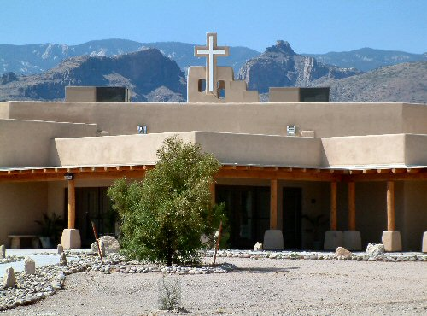

Houghton Campus

3255 N Houghton Rd

Tucson, AZ 85749

What to Expect
Desert Skies campus on Houghton Rd provides two Sunday morning opportunities to worship—8:30 and 10:00 am. We worship in the sanctuary, which is located off of Fort Lowell drive. The parking lot to the Sanctuary is on your right when you enter off the street…the first parking lot is overflow parking. We recommend entering through our Fort Lowell entrance, though there is also an entrance off of Houghton. Parking is available in front of the Fellowship Hall on the north end of campus and near the Sanctuary in two lots at the south end.
Our Welcome Kiosk is located on the patio of the Sanctuary, where our welcome team is ready to guide you into the sanctuary and answer any questions you have.
We strongly encourage everyone to wear a mask and keep a safe distance of six feet while inside. Worship services typically last around an hour and feature hymns, the choir and/or Praise Band, and special organ music. There are also times of reflective and purposed prayer, a 15-20 minute message, and opportunities to follow up with what you heard in the message through service and small group connection.
Following the service, we invite you to enjoy refreshments at Christ Café. Because we try to be sensitive to people with differing needs, we provide gluten free snacks each week. Christ Café is a great time to ask questions and meet people. Welcoming members are there to help you with your questions and to connect you with ministries and groups that you may be interested in learning about.
At Desert Skies we welcome all people into the full life of the church, as we practice “Open Hearts, Open Doors, Open Minds.”
Wear what is comfortable for you. You can "dress up" or be casual. You'll find the complete range at each of our services. You won't be singled out. Our hope is that you feel at home as soon as you enter any of our locations. We expect to have new guests every week, and welcome your questions and comments after the service.
Come be a part of a joyful community, drawing people to Christ.
We practice “Open Hearts, Open Minds, and Open Doors, as we welcome everyone into the full life of the community. We are all about: (Provide link to our statement of inclusion)

- Leading our neighbors to Christ;
- Loving one another in caring community;
- Learning to follow Jesus; and
- Living a Christ-like life that serves the world.

WHAT ABOUT MY KIDS?
Children and youth begin worship in the Sanctuary with their families. Once the children up through 5th Grade have enjoyed a special “Children’s Time,” children and middle school youth are invited to enjoy a time of age appropriate learning in special areas set up just for them.
Use this link to learn about our Safe Sanctuary policies and procedures. (Add link)
You can find out more about Desert Skies Children’s Ministry here. (This would go to a link that describes children’s ministries at Desert Skies as a whole)
Middle School and High School students from both campuses meet each week at noon for Youth Group that rotates between what we call the 4 Ss: Study, Skills, Service, and Socials. Check our youth calendar for locations.
A greeter or usher will be happy to direct you and answer any questions you have before or after the service, or call the Church Office during the week if you want to connect.

